1. Proposed Enhancements

The proposed system optimization targets the candidate-job matching algorithm through enhanced hybrid Affinda + OpenAI API (o1 model) operations with an implementation of the enrich_cv_with_openai code for CV enrichment. The system development focuses on improvement in three main areas: accuracy levels and scaling capabilities alongside workflow integration efficiency for Rainmaker Society’s operations and utilitzing sales questionnaire to refine enrichment parameters specifically for Employment Pattern & Progression and Cultural Fit Indicators.

1.1 Steps to Improve the Algorithm

1. CV Enrichment with OpenAI API

* Improved Prompt Engineering:  
  The enrich_cv_with_openai prompt requires refinement through the addition of step-by-step instructions and several sample cases demonstrating how to handle each parameter for enrichment. The model should take Employment Pattern & Progression as “Consistent growth with 3 promotions in 5 years” at the same time as Cultural Fit Indicators as “Thrives in innovative, fast-paced environments.” The approach leads to precise and context-specific results from the inferences.

1. **Functional Skills Extraction**

* **Semantic Clustering**:  
  Update the OpenAI prompt to cluster related functional skills (e.g., “Agile methodology” and “project management” under “project leadership”) and store them in the functional_skills field. This improves matching accuracy by recognizing synonymous skills.
* **Market Relevance Check**:  
  The system requires a new evaluation statement to determine market applicability of candidate skills through analysis of modern tech industry standards: “judge candidate skill value through tech sector current movement trends.” The assessment technique improves understanding between skill requirements and market trends.

1. **Scalability and Cost Optimization**

* **Batch Processing**:  
  The openAI API tool should get updated to enable running the CV processing job across multiple documents to decrease both costs and API query demands. The batch API functionality from OpenAI enables simultaneous processing of CVs that minimizes latency in the system.
* **Caching**:  
  The storage of frequently used data such as market relevance scores in cache reduces OpenAI API requests while controlling the high API price of $15 per million tokens.

**1.2 Potential Integration into HR Workflows**

1. **Integration with Rainmaker Society’s Platform**
   * **API Pipeline**:  
     The existing pipeline should include updated enrich_cv_with_openai function which enables Affinda to extract data followed by OpenAI enrichment and subsequent output processing by the matching algorithm. The system produces enriched profiles in JSON file format:

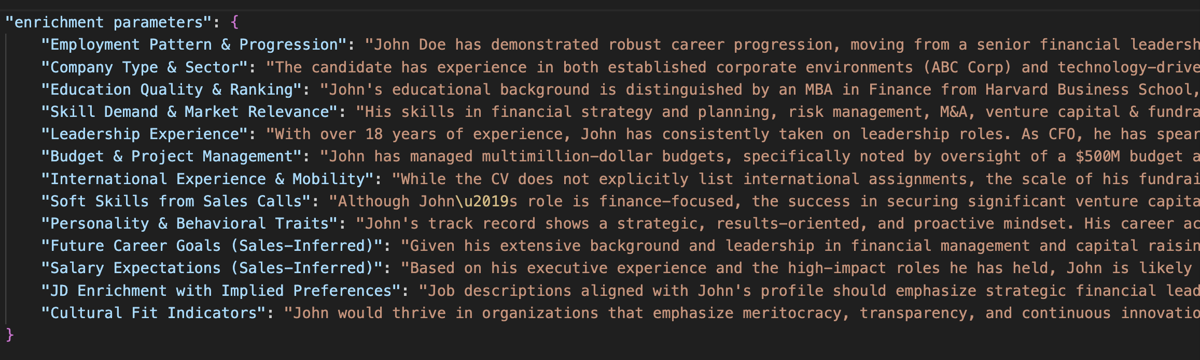

1. **Seamless HR Workflow Integration**
   * **Automated Screening**:  
     The system should arrange candidate rankings based on match scores but only keep those who reach or exceed a score of 0.8. Having decision-makers view both inferred findings and questionnaire data helps with better choices.
   * **Sales Questionnaire Integration**:  
     The company should offer standardized questions to sales staff through the system including the query “What are your long-term career goals?” The questionnaire_responses data will be saved in CV data records before enrichment with OpenAI's services continues.
   * **Job Description Optimization**:  
     The Job Description Enrichment tool with Implied Preferences enables recruiters to propose adjustments to job descriptions by including "cloud computing" skills in technical roles.
   * **Feedback Loop**:  
     Recruiters should be able to submit their evaluations of OpenAI o1 inference results and questionnaire insights for algorithm performance enhancement.

**2. Next Steps & Future Work**

**2.1 Next Steps**

* **Pilot Testing**:  
  The updated enrich_cv_with_openai function should be applied to 100 CVs together with Affinda + OpenAPI for testing. Questionnaire responses must also be integrated into this process. A/B testing should compare this implementation against the present Affinda-only process. The system monitors three performance indicators which comprise candidate placement success alongside client contentment and the algorithms' operational metrics in terms of accuracy and precision and recall statistics.
* **Cost Monitoring**:  
  OpenAI o1’s API costs should be monitored as the solution handles 500 CVs which project approximately $10,500 in expenses. Apply batch processing together with caching techniques to control expenses during system operation.
* **Recruiter and Sales Training**:  
  Direct the Human Resources teams in output interpretation through instruction on inferred parameters and questionnaire analysis comprehension. Sales team personnel should receive training about delivering standardized questionnaires to candidates.
* **Questionnaire Implementation**:  
  The sales teams will receive the questionnaire for completion while the responses must be collected through JSON structures that should feed into the pipeline.
  1. **Roadmap for Potential Expansion**

The 12–18 month project expansion includes plans for scalability while ensuring new features and extending adoption among users.

* **Phase 1: Initial Rollout (Months 1–3)**
  + The updated version of the enrich_cv_with_openai function becomes integrated with Rainmaker Society’s existing platform.
  + The system tests require 100 candidates' resumes with 10 job profiles combined with questionnaire results from tech and sales employees.
  + Gather feedback from recruiters and sales teams on the dashboard, inferred data, and questionnaire process.
  + **Deliverable**: Pilot report with performance metrics and team feedback.
* **Phase 2: Feature Expansion and Optimization (Months 4–8)**
  + The OpenAI o1 prompts will get optimized through a larger data input consisting of 5000 CVs and job descriptions along with questionnaire responses to achieve improved industry-specific performance.
  + The system should incorporate sentiment analysis technology along with integration of the OCEAN framework in its computing procedure.
  + The pipeline needs enhancement to process CVs written in Spanish and German by implementing Affinda functionalities.
  + **Deliverable**: The project will produce an enhanced algorithm system which includes capabilities to process multilingual CVs and provide questionnaire data analysis.
* **Phase 3: Scalability (Months 9–12)**
  + The system requires optimization to handle 10,000 CVs per month through OpenAI’s batch API while implementing cache functions.
  + The company should unite with alternative job sites (Xing, Stepstone) to acquire extra candidate information.
  + **Deliverable**: The orchestrated solution will achieve platform-wide distribution
* **Phase 4: Advanced Features and Market Expansion (Months 13–18)**
  + The tool adds predictive tools that calculate candidate success probabilities by examining historical data values and questionnaire responses and enrichment parameters.
  + Integrate with external HR tools (e.g., Workday) for seamless client adoption. The solution will target new markets (such as Europe and Asia) by enabling language support and regional trend integration.
  + **Deliverable**: The development process will produce a predictive algorithm improvement with external tool integration that will deploy in new market territories.

**2.3 Additional Features and External Data Sources to Explore**

1. **Sentiment Analysis Using DistilBERT**
   * The scope involves evaluating sentiment along with tone in CVs, cover letters, sales calls and questionnaire responses to obtain Personality & Behavioral Traits and Soft Skills from Sales Calls.
   * **Implementation**:  
     The unstructured text responses from questionnaires such as “What type of work environment do you thrive in?” will be analyzed by DistilBERT to determine their sentiment level of positive, neutral or negative. Positive tones will signify enthusiastic behavior leading to improvements in Cultural Fit Indicators.

* **Benefits** This approach helps to better assess candidate personalities along with soft skills which improves cultural match identification.

1. **OCEAN Framework Integration**

* The OCEAN (Big Five) framework serves as a testing method to evaluate behavioral characteristics and personnel traits for cultural match assessment.
* **Implementation**:  
  The program applies DistilBERT to process CV details and questionnaire entries to extract OCEAN personality traits including Openness, Conscientiousness, Extraversion, Agreeableness and Neuroticism through its OCEAN dataset training. The evaluation of job requirements includes application of Extraversion personality traits to sales positions.
* **Benefits**: The structured personality assessment allows improvement of Cultural Fit Indicators through this method.
* **External Data Sources to Explore**
  + Both LinkedIn and Xing Profiles provide endorsement data that enhances Skill Demand & Market Relevance and Leadership Experience sections.
  + The Job Market Trend Reports accessible through Glassdoor and Indeed provide crucial data for determining Skill Demand and Market Relevance.
  + The implied preferences in job descriptions can be enhanced through Stack Overflow and Reddit (r/sales) scraping activities.
  + Glassdoor employee reviews serve as a tool to derive company cultural values and adjust the Cultural Fit Indicators.

The structured changes to develop the talent matching algorithm while optimizing Affinda + OpenAI operations through enhanced prompt design and questionnaire integration technologies and scalability optimization features. The roadmap guides gradual expansion together with sentiment analysis capabilities and OCEAN framework abilities that strengthen personality match evaluation and cultural suitability screening. Rainmaker Society will establish a better accurate efficient scalable matching solution through these implemented strategic steps.